Practical 1, Part A: Automatic Alarm System
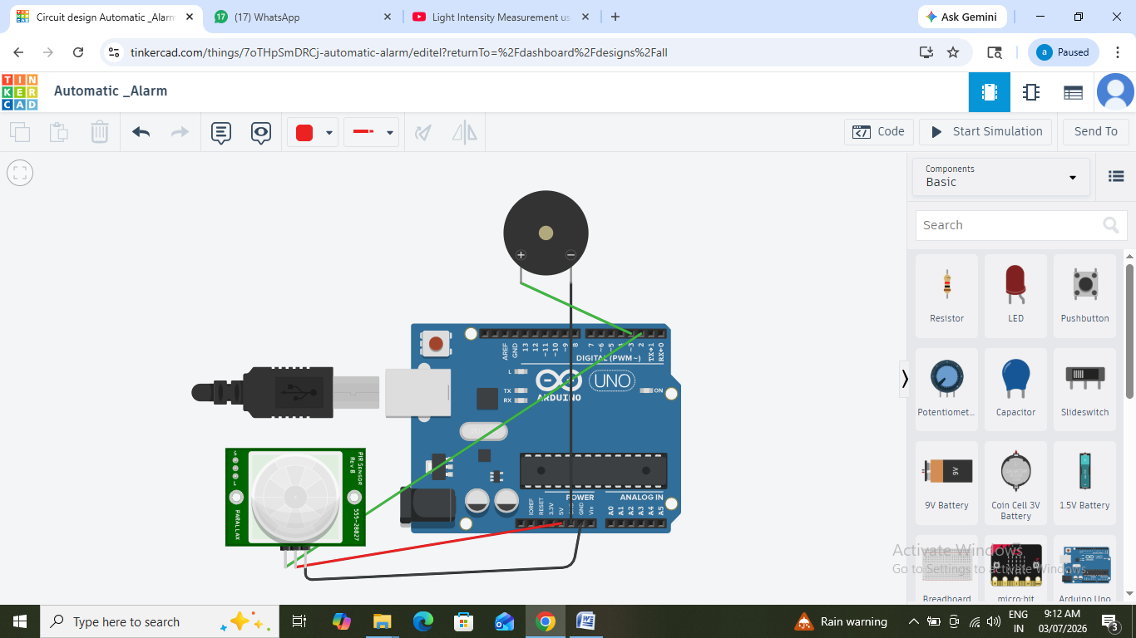
Code:
int sensorPin = 2; // PIR sensor connected to digital pin 2
int buzzerPin = 3; // Buzzer connected to digital pin 3

void setup() {
pinMode(sensorPin, INPUT); // Set sensor pin as input
pinMode(buzzerPin, OUTPUT); // Set buzzer pin as output
}

void loop() {
if (digitalRead(sensorPin) == HIGH) { // Motion detected
digitalWrite(buzzerPin, HIGH); // Turn on the buzzer
} else {
digitalWrite(buzzerPin, LOW); // Turn off the buzzer
}
}

Practical 1, Part B: Timer-Based Buzzer in Tinkercad
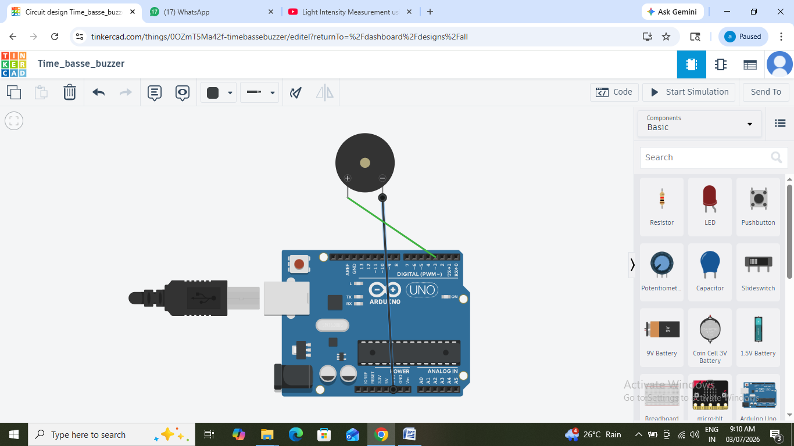
int buzzerPin = 3; // Buzzer connected to digital pin 3

void setup() {
pinMode(buzzerPin, OUTPUT); // Set buzzer pin as an output
}

void loop() {
digitalWrite(buzzerPin, HIGH); // Turn on the buzzer
delay(5000); // Keep it on for 5 seconds (5000ms)
digitalWrite(buzzerPin, LOW); // Turn off the buzzer
delay(10000); // Wait for 10 seconds before triggering again
}
Practical 1, Part C: Sensor-Based Counting Device in Tinkercad
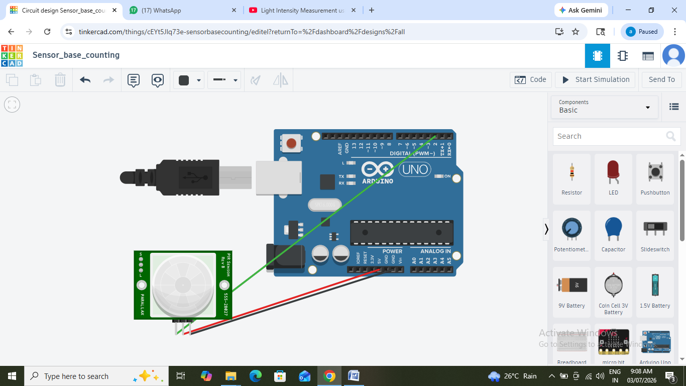

int sensorPin = 2; // Sensor signal pin connected to digital pin 2
int count = 0; // Variable to store the count
int previousState = LOW; // Store the previous state to detect transitions

void setup() {
pinMode(sensorPin, INPUT); // Set sensor pin as input
Serial.begin(9600); // Initialize serial communication
}

void loop() {
int sensorState = digitalRead(sensorPin); // Read the sensor state

// Detect a rising edge (LOW to HIGH transition)
if (sensorState == HIGH && previousState == LOW) {
count++; // Increment the count
Serial.print("Count: ");
Serial.println(count); // Display the updated count on the serial monitor
}
previousState = sensorState; // Update the previous state
}
Practical 2: Demonstrate Communication Between Two Embedded Devices Using UART Port
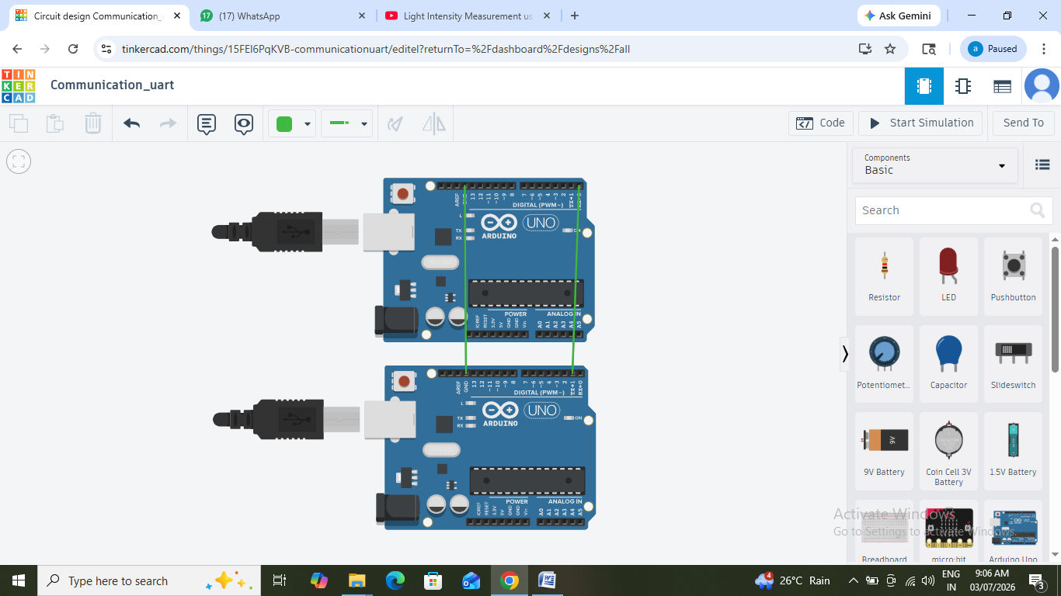

Arduino 1 Code (Transmitter):
void setup() {
Serial.begin(9600); // Start serial communication at 9600 baud rate
}

void loop() {
Serial.println("Hello from Arduino 1"); // Send a message
delay(2000); // Wait for 1 second before sending the next message
}
Arduino 2 Code (Receiver):
void setup() {
Serial.begin(9600); // Start serial communication
}

void loop() {
if (Serial.available() > 0) { // Check if data is available
String receivedData = Serial.readString(); // Read the incoming data
Serial.print("Received: ");
Serial.println(receivedData); // Print the received message to the serial monitor
}
}
Practical:-3 Ticket System
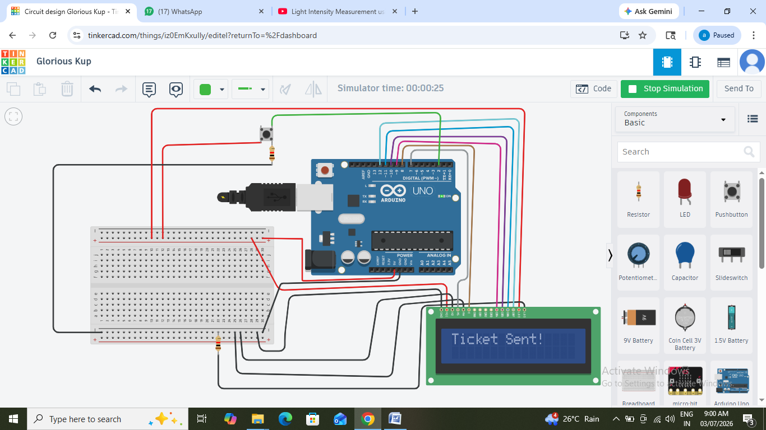
Code:-
#include <LiquidCrystal.h>

// Initialize the LCD (RS, E, D4, D5, D6, D7)
LiquidCrystal lcd(7, 8, 9, 10, 11, 12);

// Button pin
const int buttonPin = 2;
int buttonState = 0;

void setup() {
lcd.begin(16, 2); // Initialize the LCD
pinMode(buttonPin, INPUT); // Set button pin as input
lcd.print("Ticket System");
delay(2000); // Display initial message for 2 seconds
lcd.clear();
lcd.print("Press Button");
}

void loop() {
buttonState = digitalRead(buttonPin); // Read button state
if (buttonState == HIGH) { // If button is pressed
lcd.clear();
lcd.print("Ticket Sent!");
delay(3000); // Hold message for 3 seconds
lcd.clear();
lcd.print("Press Button");
}
}
Practical:-4 Movement & Orientation of Phone
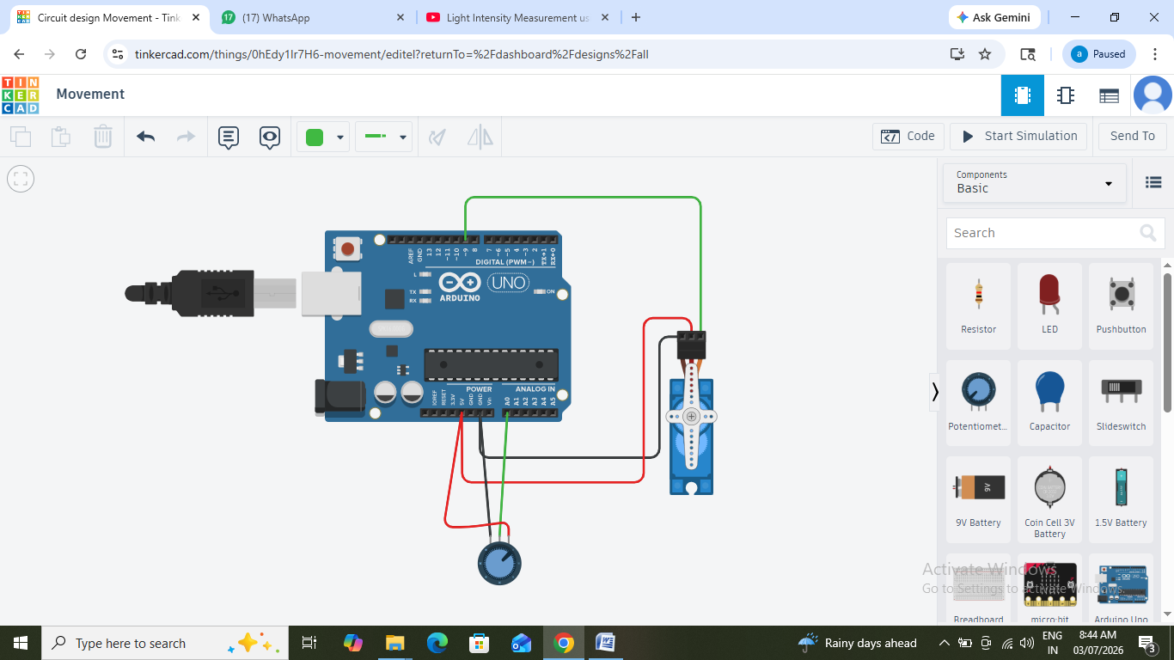
#include <Servo.h>
#include <SoftwareSerial.h>

int pos = 0;
int sensorValue = 0;
int i = 0;
Servo servo_9;

void setup(){
servo_9.attach(9);
pinMode(A0, INPUT);
pinMode(13, OUTPUT);
Serial.begin(9600);
}

void loop(){

sensorValue = analogRead(A0);
pos = map(sensorValue,0,1023,0,180);

for (i = 0; i <= pos; i++) {
if(i == 90){
Serial.println("Landscape");
} else if( i == 180 || i == 0){
Serial.println("Portrait");
}
servo_9.write(i);
delay(15);
}
for (i= pos; i >= 0; i --) {
if(i == 90){
Serial.println("Landscape");
}
servo_9.write(i);
delay(15);
}
}
Practical:-5
Practical:-6 Water level in tank
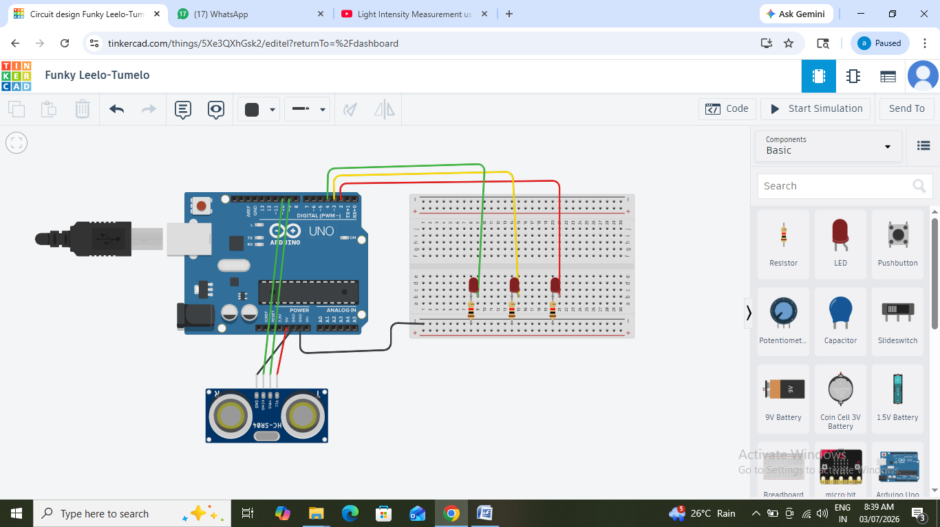
// HC-SR04 Pins
const int trigPin = 9;
const int echoPin = 10;

// LEDs
const int redLED = 2;
const int yellowLED = 3;
const int greenLED = 4;

long duration;
int distance;

void setup() {
pinMode(trigPin, OUTPUT);
pinMode(echoPin, INPUT);

pinMode(redLED, OUTPUT);
pinMode(yellowLED, OUTPUT);
pinMode(greenLED, OUTPUT);

Serial.begin(9600);
}

void loop() {

// Send ultrasonic pulse
digitalWrite(trigPin, LOW);
delayMicroseconds(2);

digitalWrite(trigPin, HIGH);
delayMicroseconds(10);
digitalWrite(trigPin, LOW);

// Read echo
duration = pulseIn(echoPin, HIGH);

// Distance in cm
distance = duration * 0.034 / 2;

Serial.print("Distance = ");
Serial.print(distance);
Serial.println(" cm");

// Water Level
if (distance > 20) { // Tank almost empty
digitalWrite(redLED, HIGH);
digitalWrite(yellowLED, LOW);
digitalWrite(greenLED, LOW);
}
else if (distance > 10) { // Medium level
digitalWrite(redLED, LOW);
digitalWrite(yellowLED, HIGH);
digitalWrite(greenLED, LOW);
}
else { // Tank full
digitalWrite(redLED, LOW);
digitalWrite(yellowLED, LOW);
digitalWrite(greenLED, HIGH);
}

delay(500);
}
Practical:-7 Intensity of light
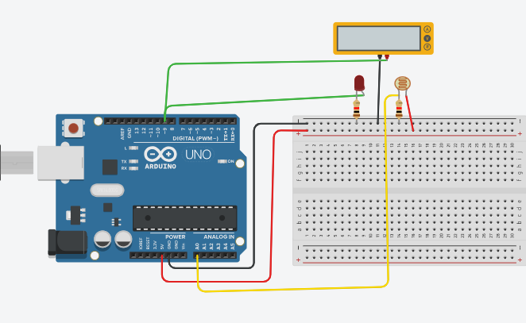
Code:-
int sensorvalue = 0;
void setup()
{
pinMode(A0, INPUT);
Serial.begin(9600);
pinMode(9,OUTPUT);
}
void loop()
{

sensorvalue=analogRead(A0);
Serial.println(sensorvalue);
analogWrite(9,map(sensorvalue,0,1023,0,255));
delay(100);
}

Practical:-8 Motion detection
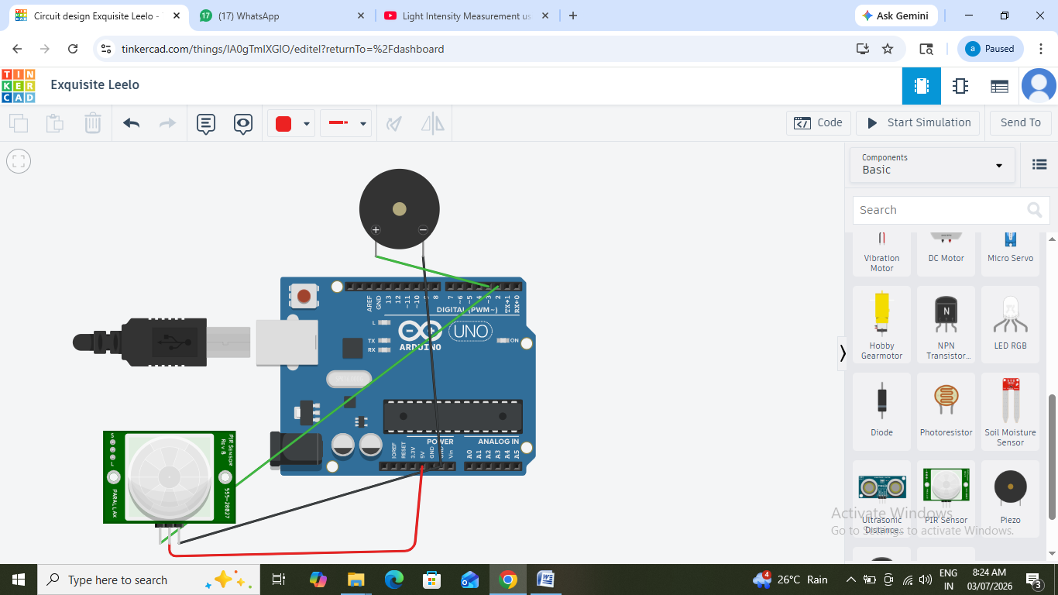
Code:-
int buzz=3;
int pir=2;
void setup()
{
pinMode(buzz, OUTPUT);
pinMode(pir, INPUT);
Serial.begin(9600);
}
void loop()
{
int status=digitalRead(pir);
if(status==HIGH)
{
Serial.println("Motion detectev");
tone(buzz,1000,700);
delay(2000);
}
else
{
Serial.println("No one is there");
delay(1000);
}
}

